# Task 2

For task 2 we discovered the day of the submission that there was some errors in our comments dataframe from week 1, and when we tried to fix it we got an error message saying:  "Exception: Unable to connect to [pushshift.io](http://pushshift.io/). Max retries exceeded.»

And after googling and checking the pushshift website we found out the service was down so we couldn’t fix the errors, therefore there are some errors in the answers in task 2.

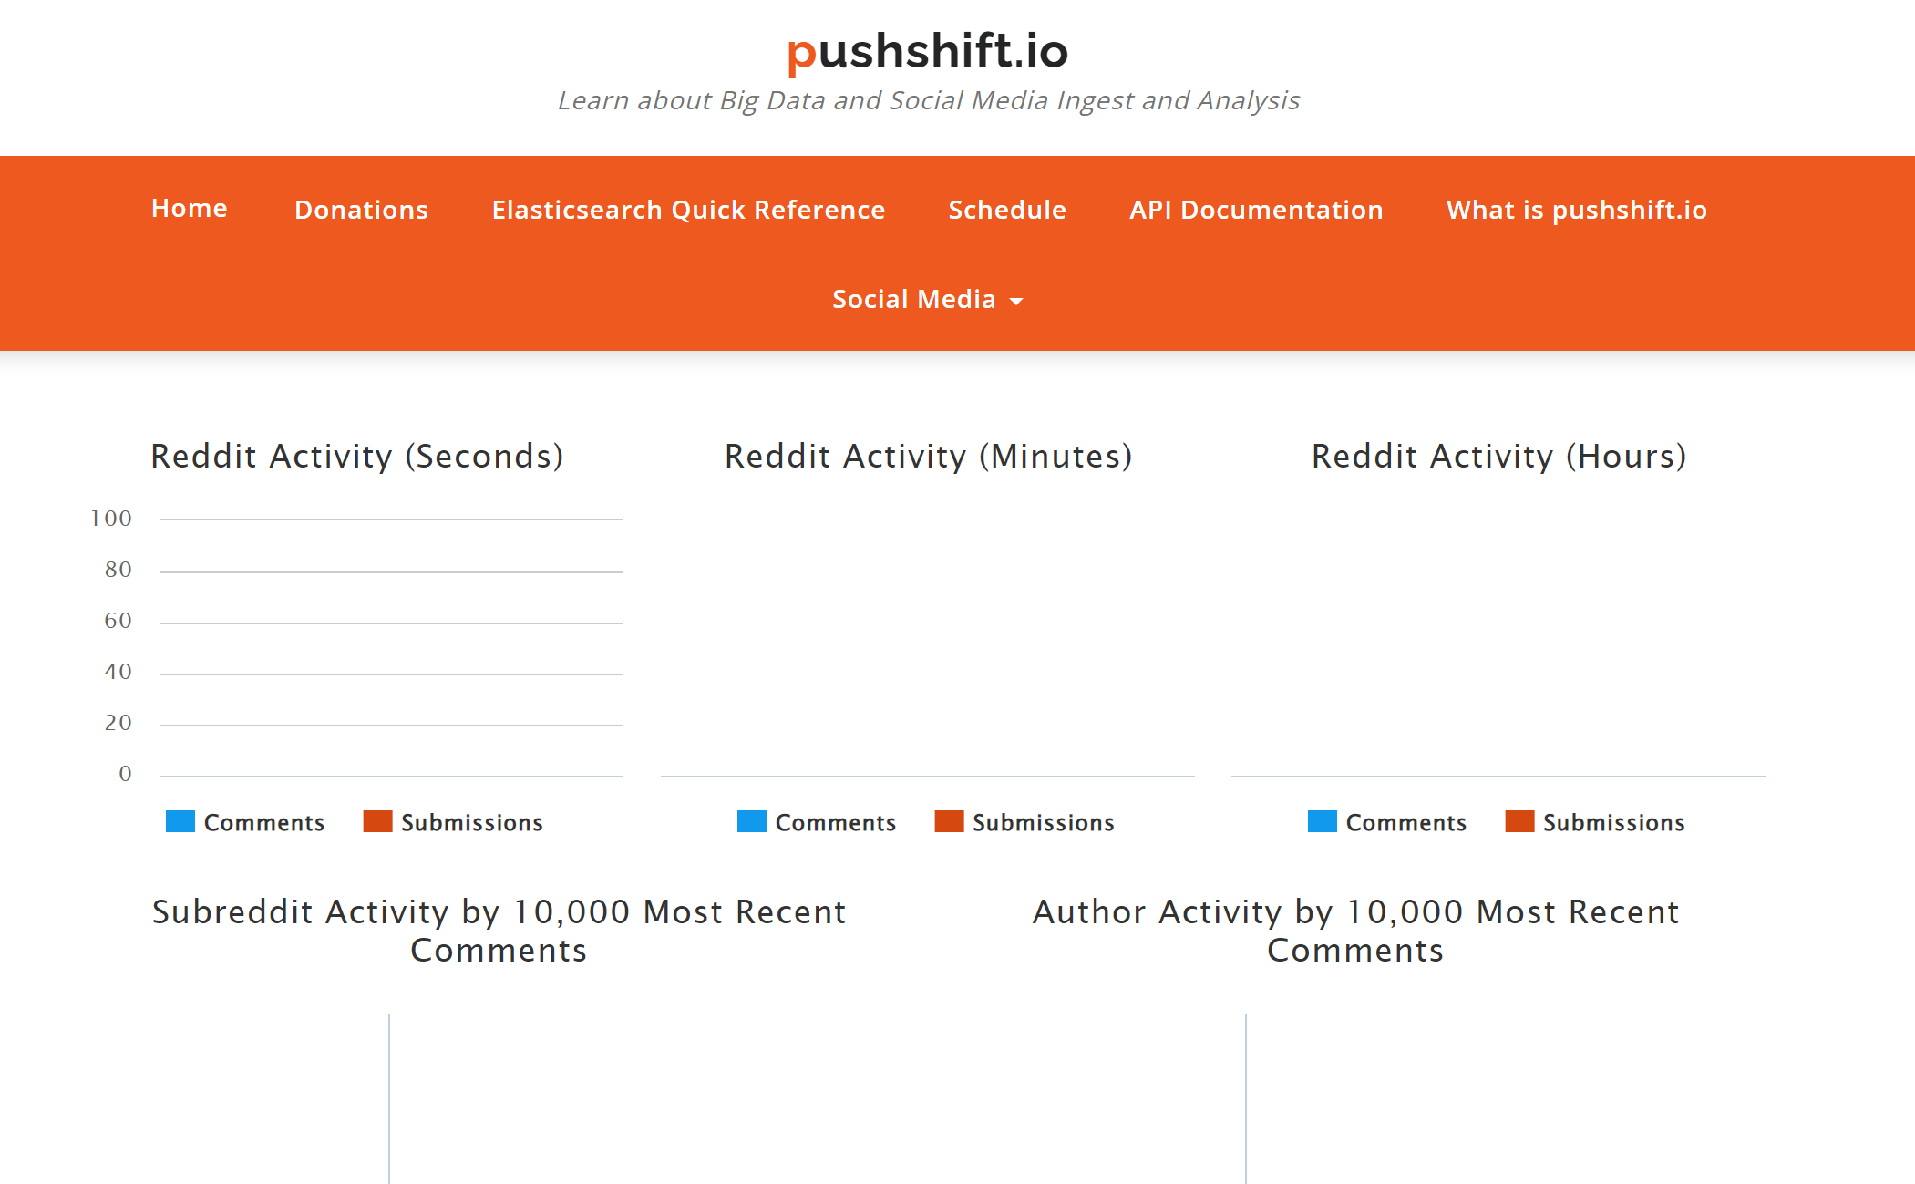

# Task 4

Our task 4 is weak. We have made some code, but we’re missing the direct network from week 3 task 3 so we cant get the correct answers. And also while working on week 3 task 3 we found out we needed the datasets from week 1 which also there was an error in as mentioned above with the pushshift being down on Friday and Tuesday so we lost a lot of time to problems that wasn’t in our hands (could/should have been done earlier perhaps, but we didn’t realise that we needed all these earlier files for the assignment, which I guess might be our bad). So at least we put in some code for the variables we should have had.